ASSIGNMENT NO. 1

Introduction to Databases and SQL Environment

Q1) Write SQL commands to create a database named SchoolDB.
The program should:
  - Create a new database named SchoolDB.
  - Select the database for use.
  - Display confirmation by creating a simple table inside it.

CREATE DATABASE SchoolDB;
USE SchoolDB;
CREATE TABLE Student (
StudentID INT PRIMARY KEY,
StudentName VARCHAR(50),
Age INT
);
SHOW TABLES;

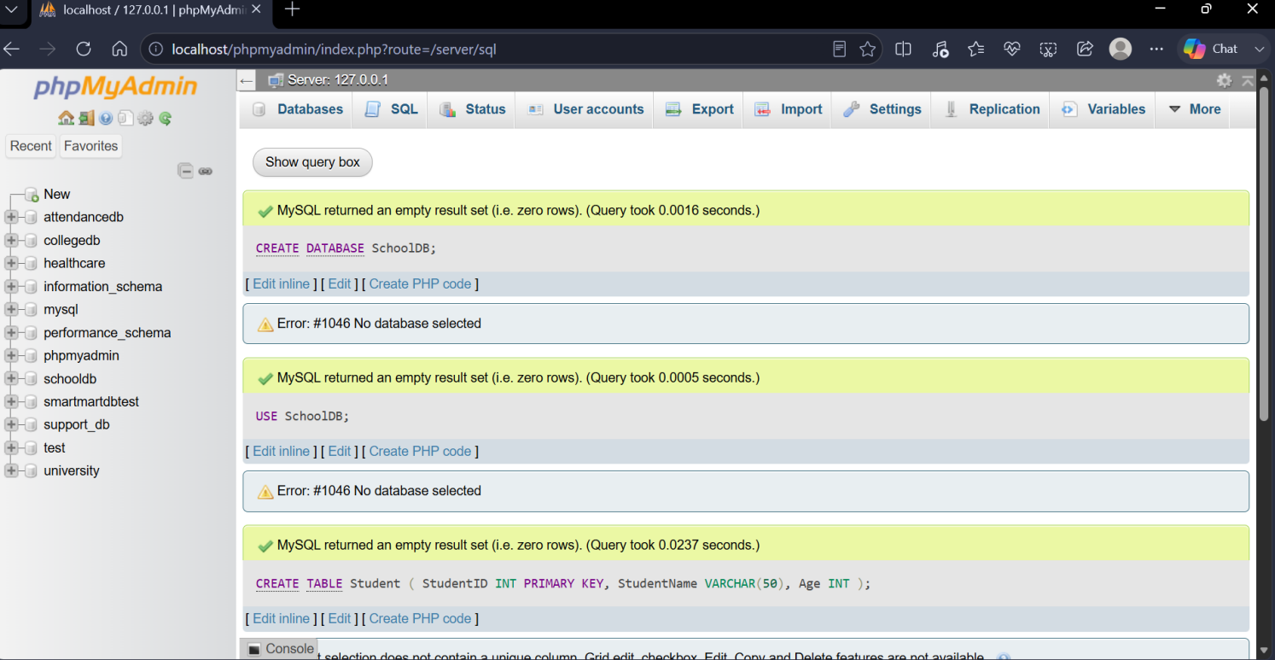

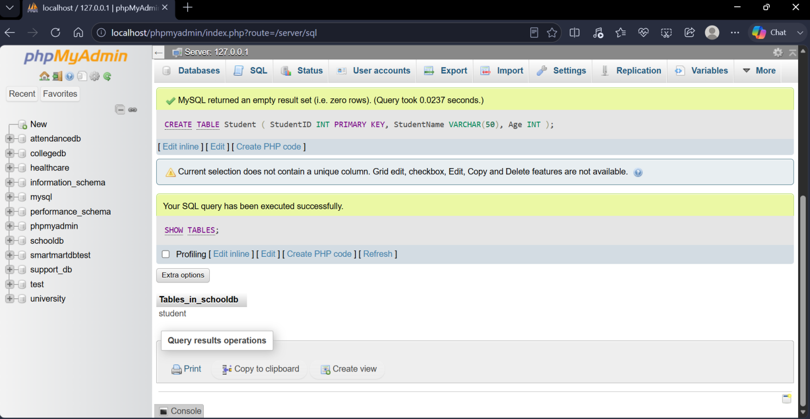

Q2) Create a table named Student with the following columns:
Column Name | Data Type | Constraint
StudentID | INT | PRIMARY KEY
StudentName | VARCHAR(50) | NOT NULL
Age | INT
ClassName | VARCHAR(20)
City | VARCHAR(30)
The program should:
- Create the table.
- Define proper data types.
- Apply primary key on StudentID.

CREATE TABLE Student (
StudentID INT PRIMARY KEY,
StudentName VARCHAR(50) NOT NULL,
Age INT,
ClassName VARCHAR(20),
City VARCHAR(30)
);

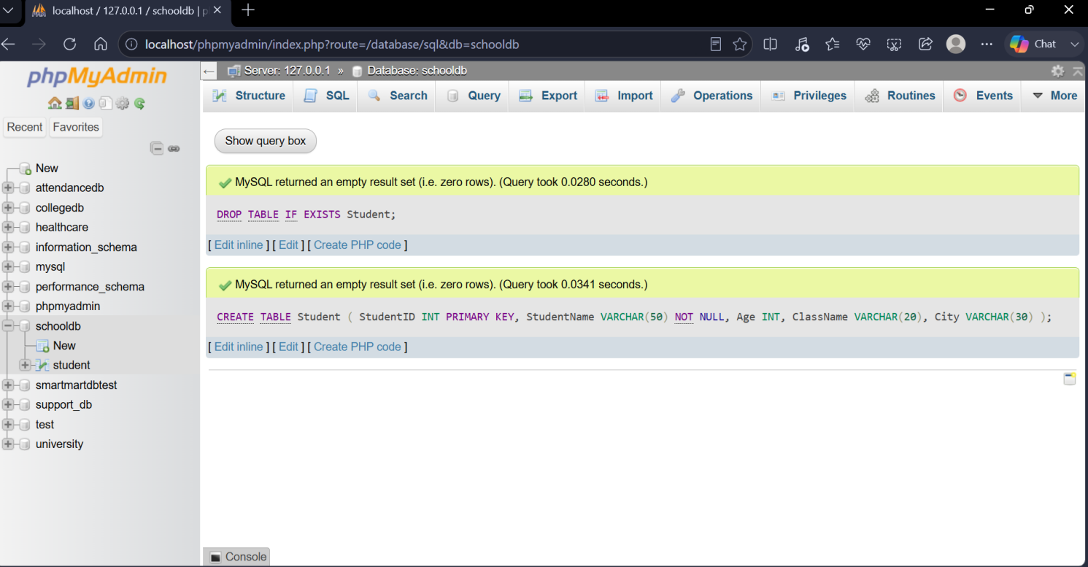

Q3) Insert at least 10 records into the Student table.
The records should include:
- Student ID
- Student name
- Age
- Class name
- City
After inserting data, display all records using the SELECT command.

INSERT INTO Student (StudentID, StudentName, Age, ClassName, City)
VALUES
(1, 'Aarav Shah', 18, 'FYBSc IT', 'Mumbai'),
(2, 'Meera Joshi', 19, 'FYBCA', 'Pune'),
(3, 'Rohan Patil', 20, 'SYBSc IT', 'Nashik'),
(4, 'Ananya Sen', 18, 'FYBSc CS', 'Mumbai'),
(5, 'Kabir Verma', 19, 'SYBCA', 'Thane'),
(6, 'Isha Gupta', 20, 'SYBSc CS', 'Pune'),
(7, 'Aditya Rao', 18, 'FYBSc IT', 'Nagpur'),
(8, 'Sanya Malhotra', 21, 'TYBSc IT', 'Mumbai'),
(9, 'Vidyut Nair', 19, 'FYBCA', 'Thane'),
(10, 'Tanvi Deshmukh', 20, 'SYBSc CS', 'Pune');

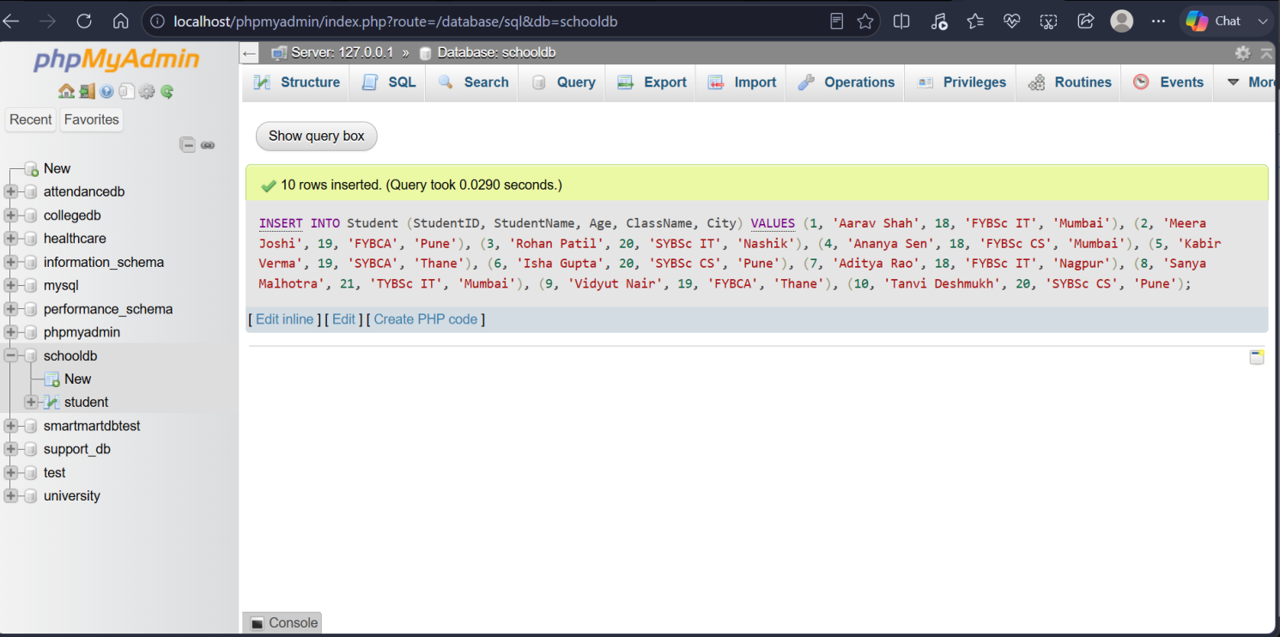

Q4) Create a table named Course with the following fields:
Column Name | Data Type
CourseID | INT
CourseName | VARCHAR(50)
Duration | VARCHAR(20)
Fees | DECIMAL(10,2)
The program should:
- Create the table.
- Add a primary key on CourseID.
- Insert at least 5 course records.
- Display all course records.

CREATE TABLE Course (
CourseID INT PRIMARY KEY,
CourseName VARCHAR(50),
Duration VARCHAR(20),
Fees DECIMAL(10,2)
);

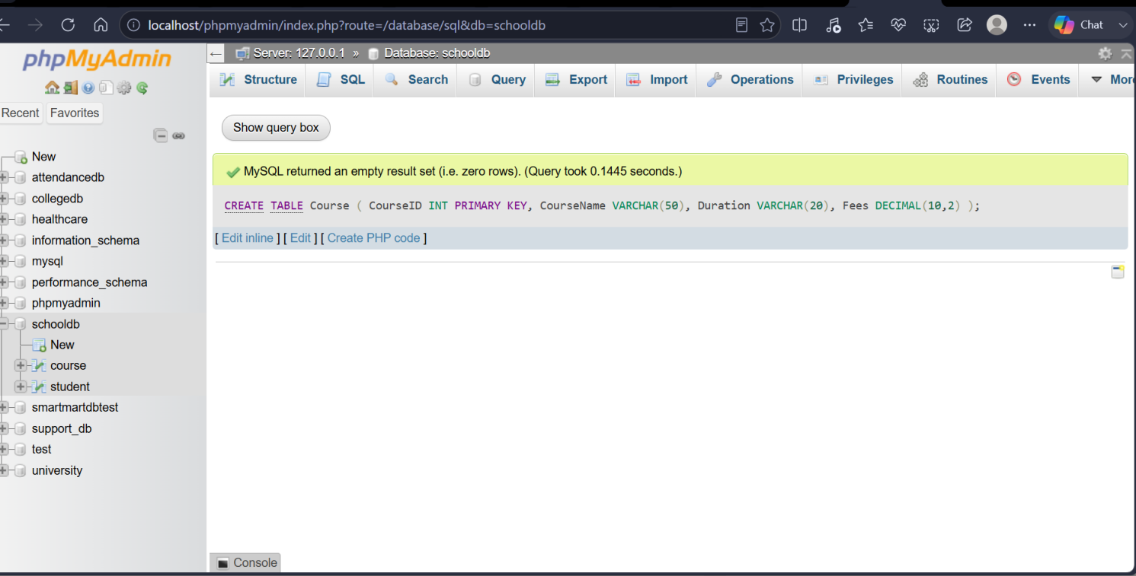

INSERT INTO Course (CourseID, CourseName, Duration, Fees)
VALUES
(1, 'SQL Mastery', '2 Months', 4500.00),
(2, 'Python Basics', '3 Months', 6000.50),
(3, 'Java Pro', '4 Months', 8000.00),
(4, 'Web Dev Boot', '6 Months', 12000.75),
(5, 'Data Science', '6 Months', 15000.00);
SELECT * FROM Course;

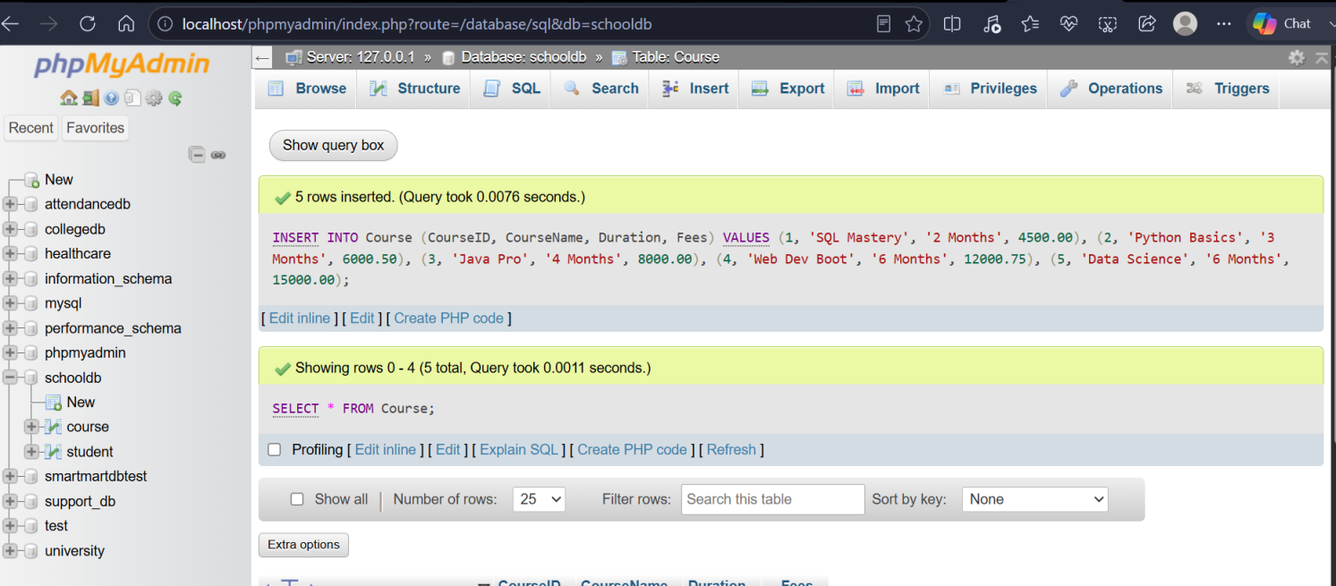

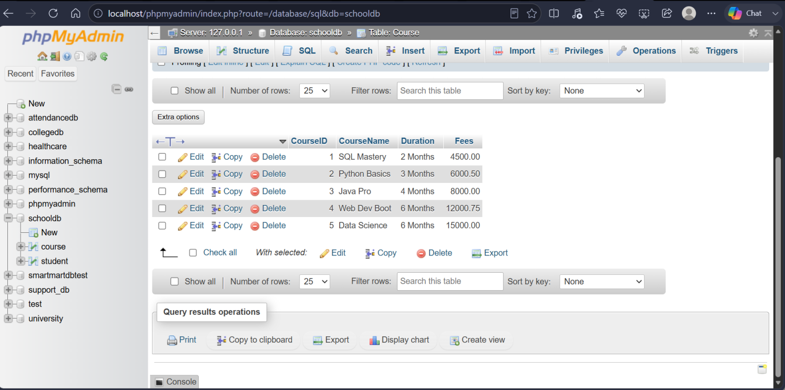

Q5) Write SQL queries to display only selected columns from the Student table.
Display:
- StudentName
- ClassName
- City
Expected output should show only these three columns.

Select StudentName, ClassName, City
FROM Student;

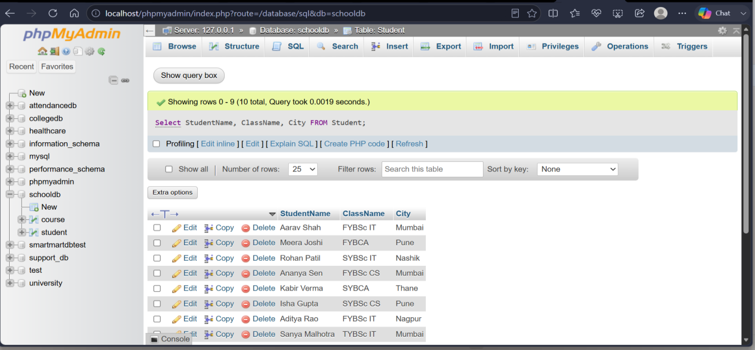

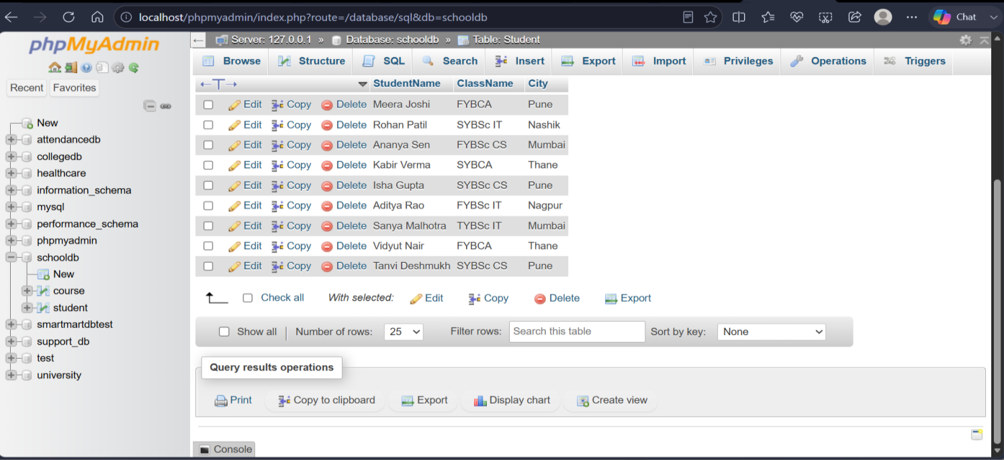

Q6) Write SQL commands to view the structure of the Student table.
Use the suitable command according to the database environment:
Database | Command
MySQL | DESC Student;
PostgreSQL | tudent
SQLite | PRAGMA table_info(Student);

--MYSOL Environment
DESC Student;………(only run this)
--postgreSQL Environment
\d Student
--SQLite Environment
PRAGMA table_info(Student);

DESC Student;

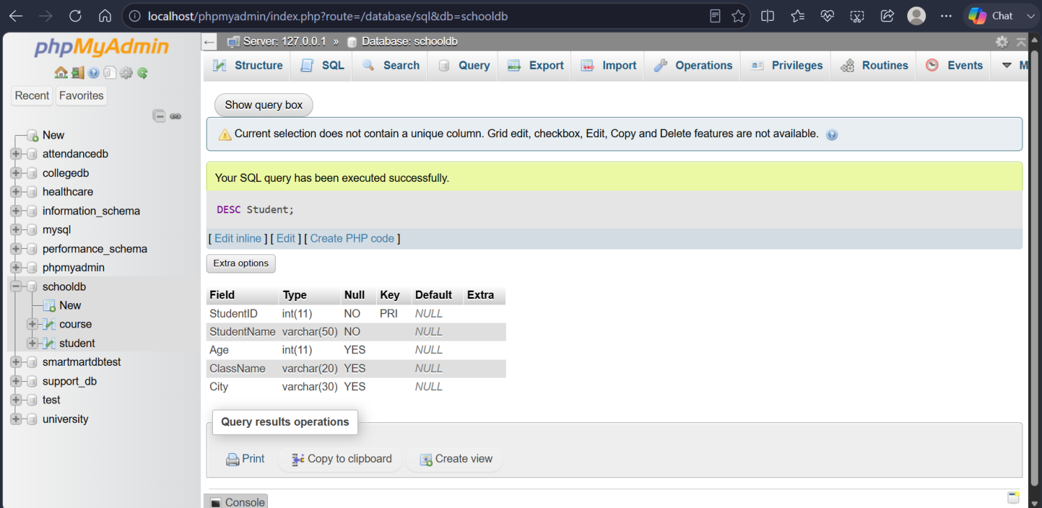

Q7) Prepare a CSV file named students.csv and import it into the Student table.
The CSV file should contain:
StudentID | StudentName | Age | ClassName | City
1 | Aarav Shah | 18 | FYBSc IT | Mumbai
2 | Meera Joshi | 19 | FYBCA | Pune
3 | Rohan Patil | 20 | SYBSc IT | Nashik
The task should include:
- Creating a matching table.
- Importing the CSV file.
- Displaying imported records using SELECT.

LOAD DATA INFILE 'C:/Users/Acer/OneDrive/Desktop/SEM3/DBMS/Students.csv'
INTO TABLE CSV_Student
FIELDS TERMINATED BY ','
ENCLOSED BY '"'
LINES TERMINATED BY '\n'
IGNORE 1 ROWS;

SELECT * FROM CSV_Student;

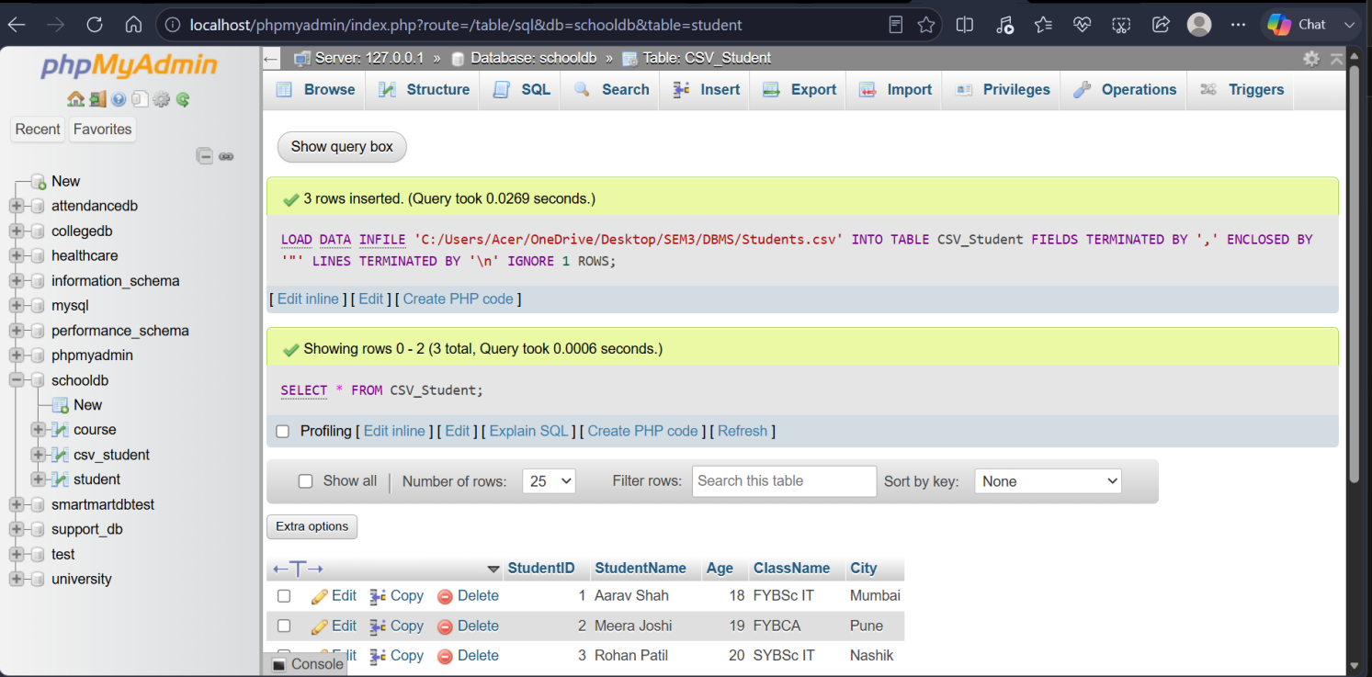

Q8) Create a database named EmployeeDB and a table named Employee.
The table should contain:
Column Name | Data Type
EmployeeID | INT
EmployeeName | VARCHAR(50)
Department | VARCHAR(30)
Salary | DECIMAL(10,2)

Column Name | Data Type
City | VARCHAR(30)
The program should:
- Create the database.
- Create the Employee table.
- Insert 8 employee records.
- Display all employee records.

CREATE DATABASE EmployeeDB;
USE EmployeeDB;

CREATE TABLE Employee (
EmployeeID INT PRIMARY KEY,
EmployeeName VARCHAR(50),
Department VARCHAR(30),
Salary DECIMAL(10, 2),
City VARCHAR(30)
);

INSERT INTO Employee
VALUES
(101, 'John Doe', 'IT', 75000.00, 'New York'),
(102, 'Jane Smith', 'HR', 65000.00, 'Chicago'),
(103, 'Sam Brown', 'Finance', 82000.00, 'Boston'),
(104, 'Lisa Ray', 'IT', 78000.00, 'Seattle'),
(105, 'Mark Lee', 'Sales', 60000.00, 'Austin'),
(106, 'Anna Kim', 'Marketing', 68000.00, 'Denver'),
(107, 'Paul Jay', 'Finance', 81880.00, 'Miami'),
(108, 'Emma Watson', 'HR', 66000.00, 'Dallas');
SELECT * FROM Employee;

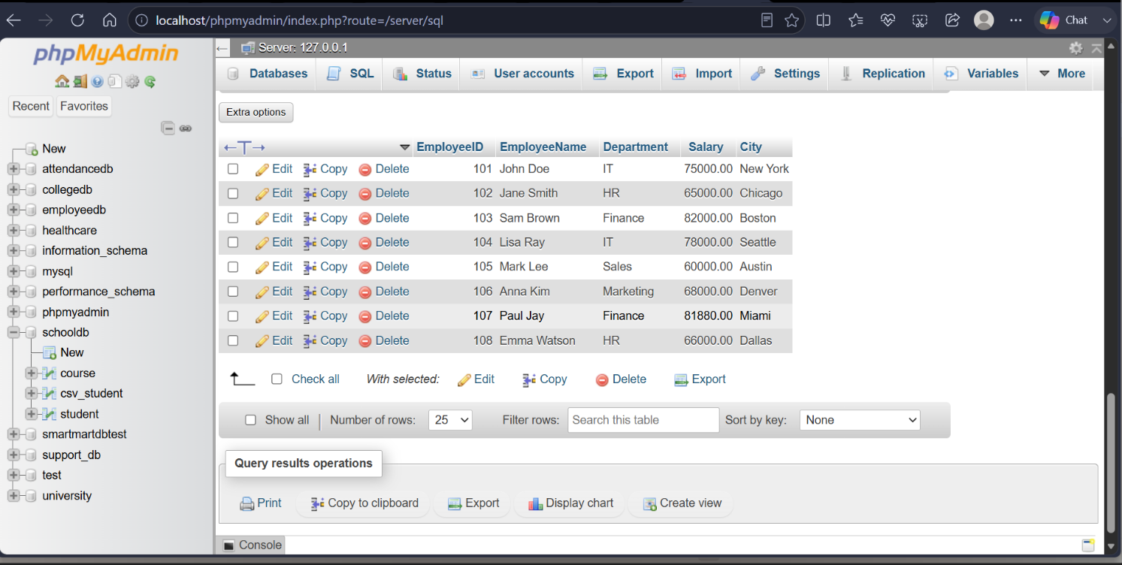
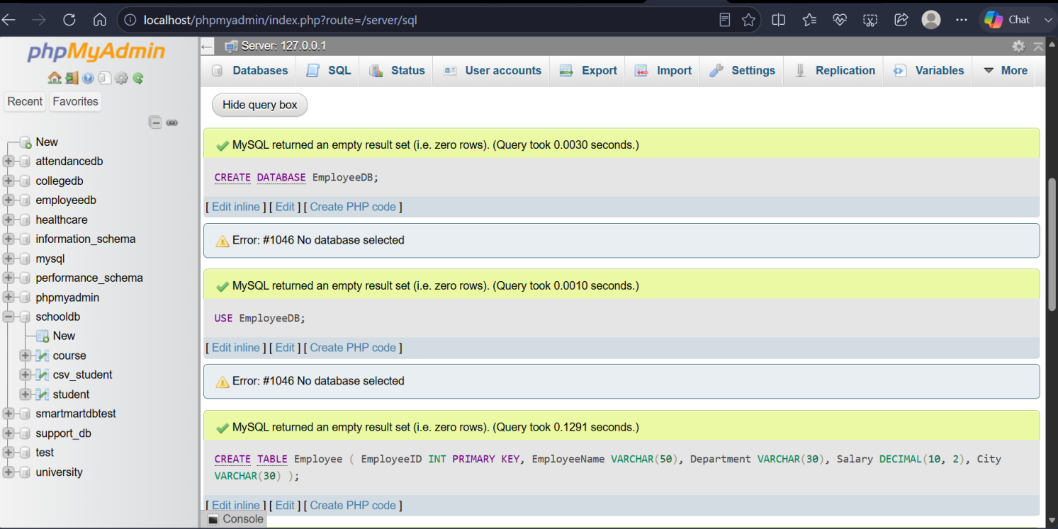
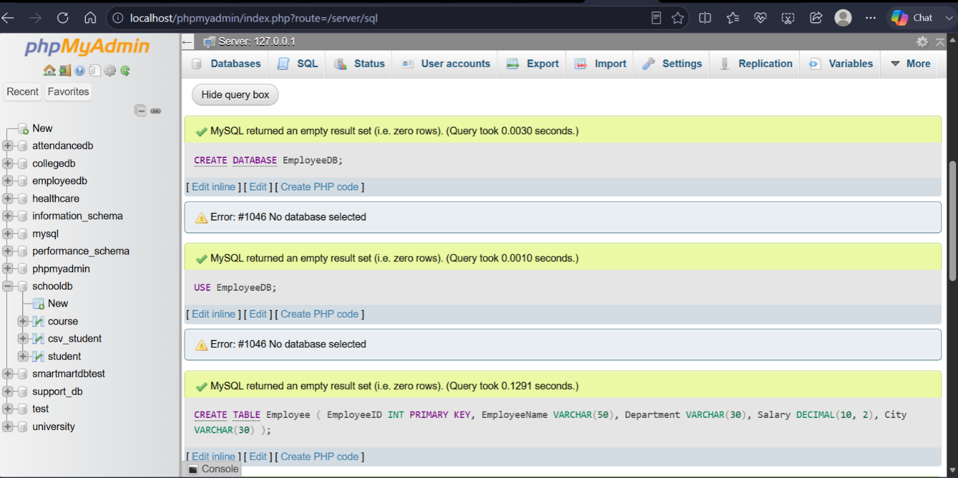

Q9) Write SQL queries to compare the difference between SELECT * and selecting specific columns.
The task should include:
- Query using SELECT * FROM Student;
- Query using SELECT StudentName, City FROM Student;
- Write two lines explaining the difference between both outputs.

SELECT * FROM Student;

SELECT StudentName, City FROM Student;

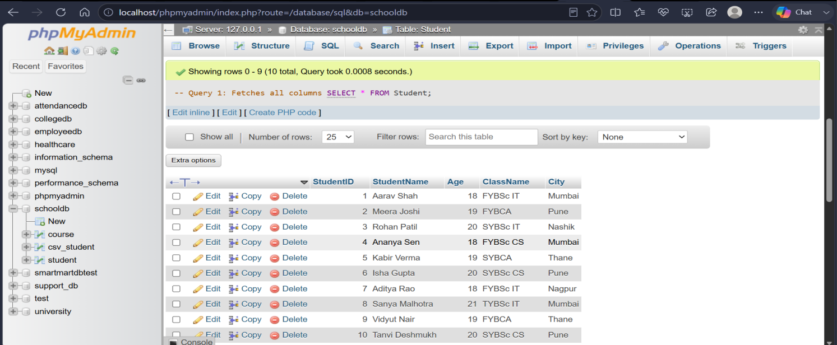

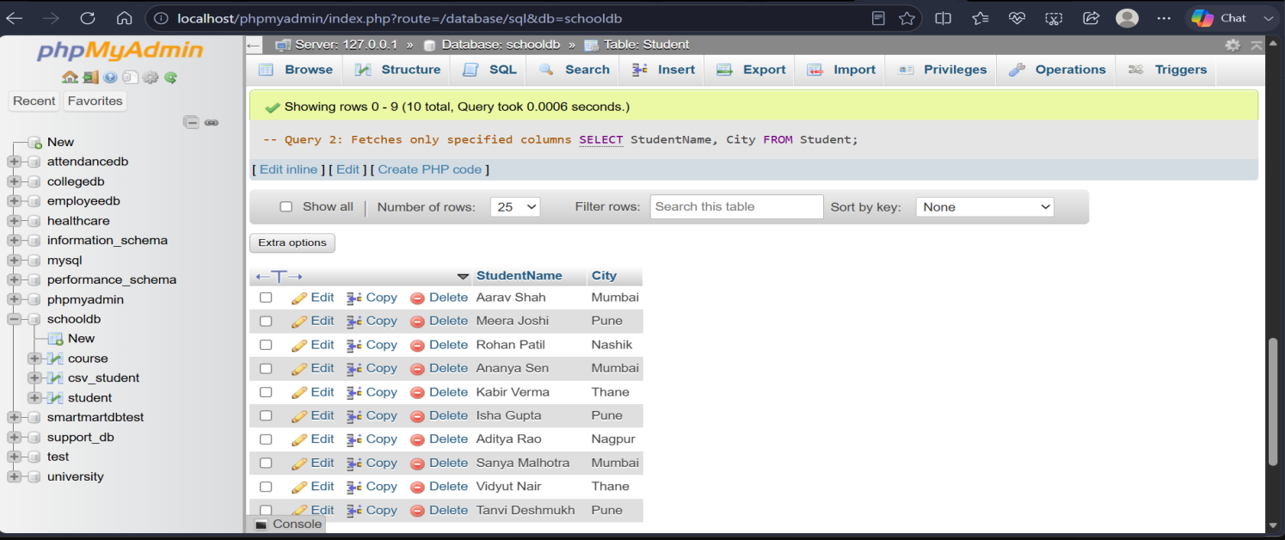

Q10) Create a complete SQL script for a mini college database.
The script should include:
- Creating database MiniCollegeDB.
- Creating tables Student, Course, and Faculty.
- Adding suitable columns and data types.
- Inserting at least 5 records in each table.
- Displaying all records from each table.
- Viewing the structure of each table.

CREATE DATABASE MiniCollegeDB;
USE MiniCollegeDB;

-- Create Tables
CREATE TABLE Student (SID INT PRIMARY KEY, SName VARCHAR(50));
CREATE TABLE Course (CID INT PRIMARY KEY, CName VARCHAR(50));
CREATE TABLE Faculty (FID INT PRIMARY KEY, FName VARCHAR(50));

-- Insert Records
INSERT INTO Student VALUES (1,'Ali'), (2, 'Ben'), (3, 'Cam'), (4, 'Dan'), (5, 'Eve');
INSERT INTO Course VALUES (10, 'Math'), (11, 'Sci'), (12, 'Art'), (13, 'Lit'), (14, 'CS');
INSERT INTO Faculty VALUES (100, 'Dr.X'),(101, 'Dr.Y'),(102,'Dr.Z'), (103, 'Dr.A'), (104, 'Dr.B');

-- View Tables
SELECT * FROM Student;
SELECT * FROM Course;
SELECT * FROM Faculty;

-- View Structure
DESC Student;
DESC Course;
DESC Faculty;

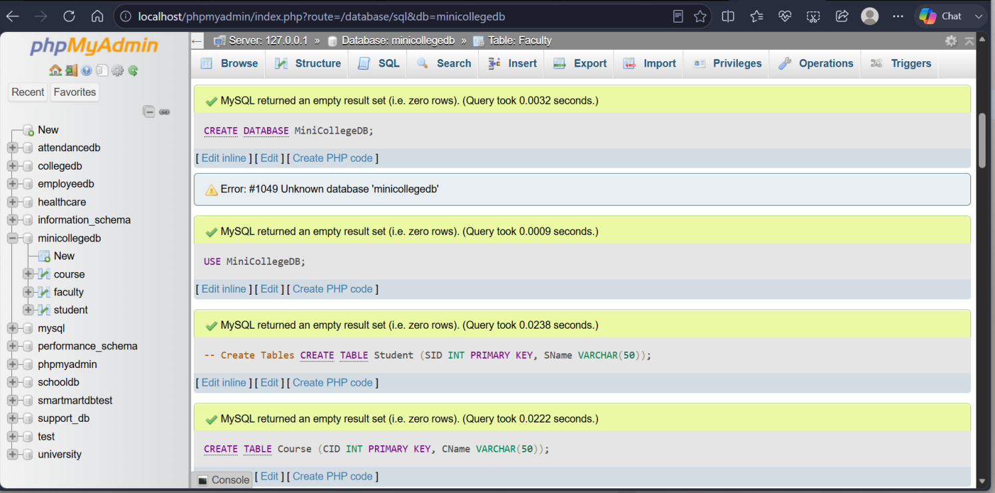

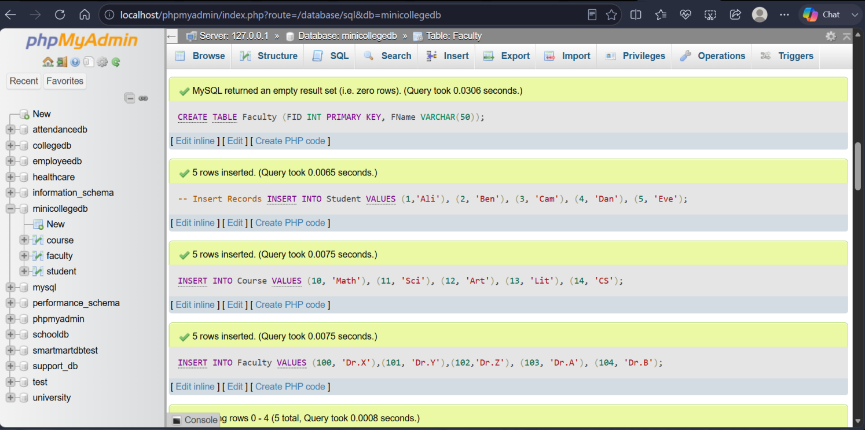

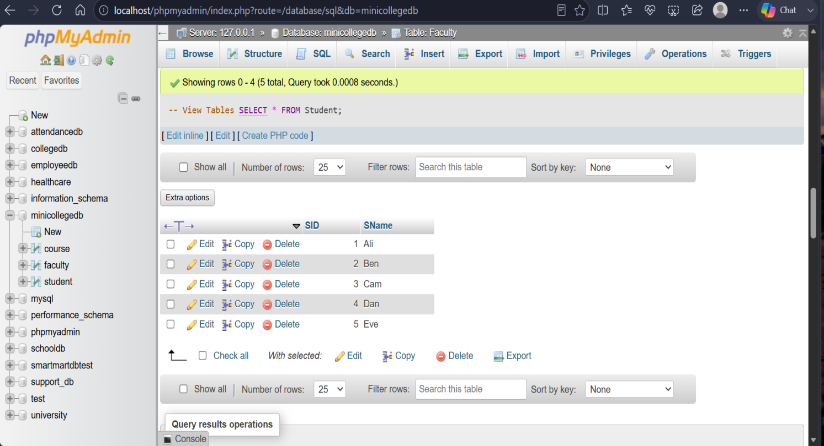

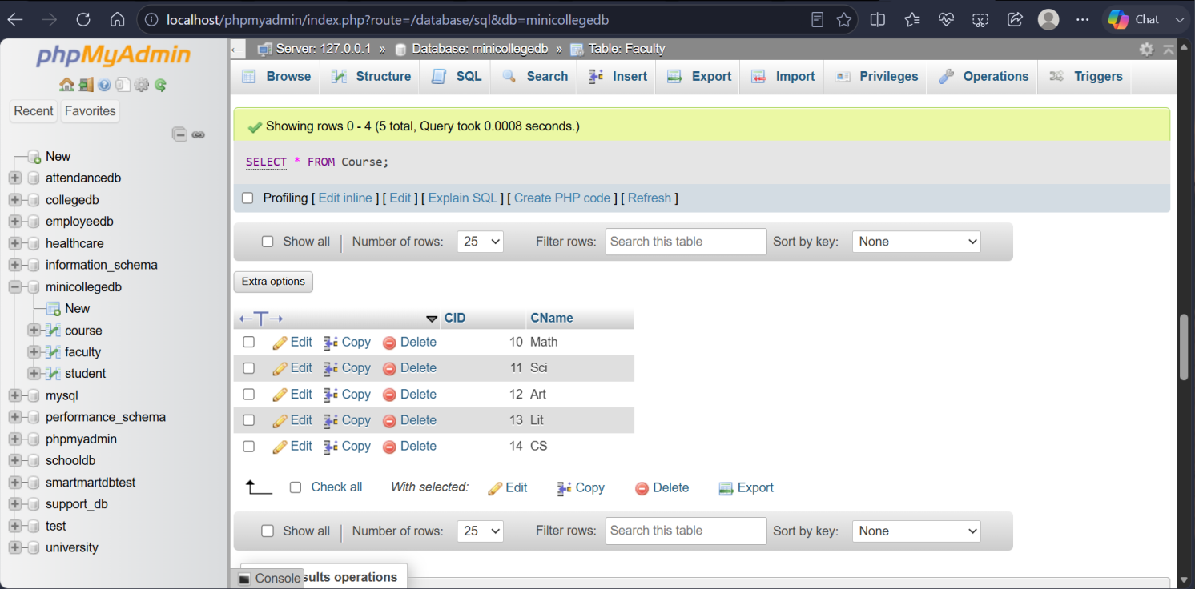

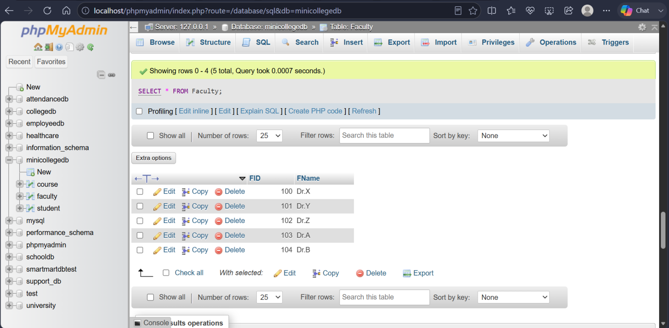

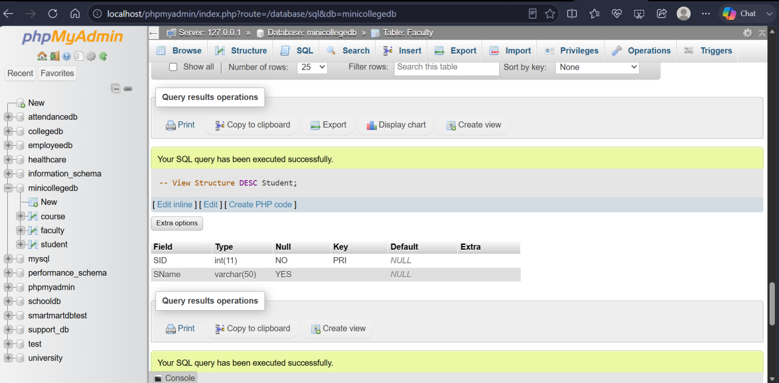

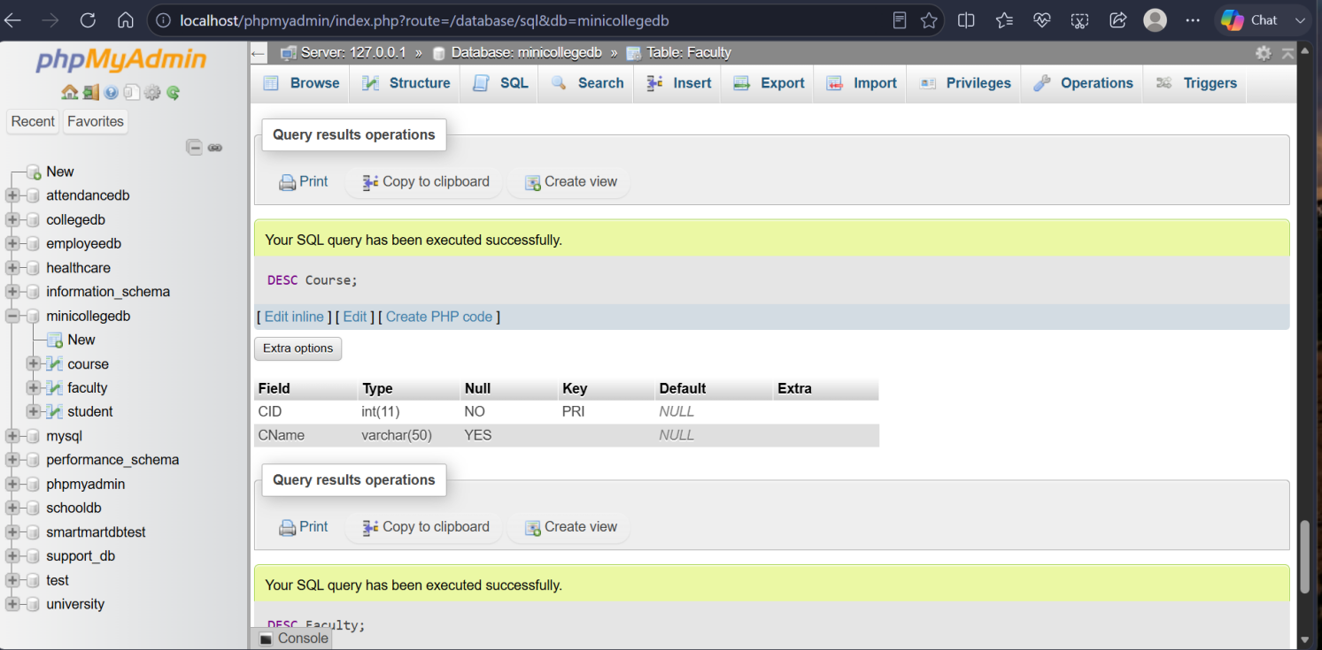

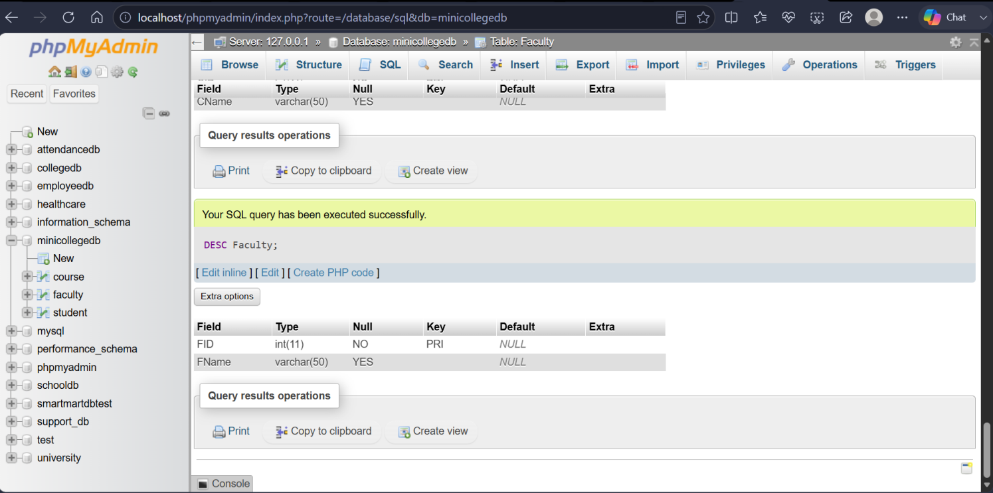

THANK YOU

